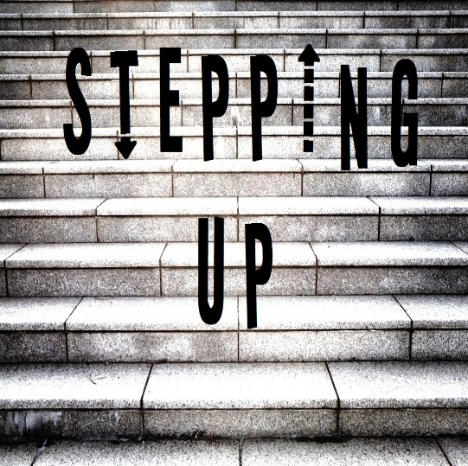

Lower Pacific District Annual Conference March 4-5 2016

R e g i s t r a t i o n F o r m
☐ | Delegate
☐ | Pastor
☐ | Guest
☐ | Other

First Name: Click here to enter text.
☐ | Entire Conference - $50 ($30 for Islanders)
☐ | Friday afternoon workshop - $10
☐ | Friday celebration dinner - $30
☐ | Saturday morning seminar - $15 (lunch included)
☐ | Saturday morning ladies lunch
☐ | Saturday business meeting
 | Total $ Click here to enter text.
☐ | I will need childcare for 1-2 children
☐ | I will need childcare for 3-4 children
Surname Click here to enter text.

Yes, I/we plan to attend:





